|  |  |  |
| --- | --- | --- |
| Department of Gender, Youth and Social Services | | |
|  | FIRE AND DISASTER CASE INQUIRY. |  |

**Date 16th OCTOBER, 2024**

***Bio Data***

**Name of Client**: Elnasio Gichuki – Represented by Waithera Nderitu

**Sex:** [X] Male [ ] Female Other specify …………

**Cell phone number**: 0720427508 **ID Number**: 23541432 **Age**:40years

**Alternative contact person:** N/A

**Contact**: N/A

***(If more than one, capture details on the next page)***

**Sub-County:** Othaya  **Ward:** Iriaini Sub-Location: Kiademi

Village: Mathome Nearest Landmark: Mathome Tea Buying Centre

Name of case Identifier: Office

Contact Information for the case identifier:

Relationship with the client:

Does the client own the land they are currently living in? [X] Yes [ ] No

What is the source of water for the family? Tap

If not in the homestead compound, approximately how far is it? **N/A**

What is the monthly average income for the household? N/A

Was the fire brigade contacted: No

***Information details for adults living in the home***

|  |  |  |  |  |  |
| --- | --- | --- | --- | --- | --- |
|  | **Names** | **Sex** | **Age in years** | **Relationship with the client** | **Current economic occupation/activity** |
| 1 | Elnasio Gichuki | M | 45 | Client | Tea Farmer |
| 2 | Bianca Wambui | F | 40 | Wife | Tea farmer |
|  |  |  |  |  |  |
|  |  |  |  |  |  |

***Capture details for the school going children in the home***

|  |  |  |  |  |  |
| --- | --- | --- | --- | --- | --- |
|  | **Names** | **Sex** | **Age in years** | **Names of school currently attending** | **Class/3** |
| 1 | Judy Muthoni | F | 17 | St. Maria Gorretti | FORM 3 |
| 2 | Joseph Nderitu | M | 14 | Ruruguti Primary school | Grade 8 |
| 3 | Robert Wachira | M | 7 | Ruruguti Primary School | Grade 1 |

***Summary of finding.***

The case concerns Elnasio Gichuki from Kiademi sub-location, who was represented by her sister Waithera Nderitu is seeking assistance after a devastating fire destroyed her family's home on October 13, 2024, around 10:00 am.

The clients were in church when the incident occurred and it is a neighbor who spotted the fire and raised alarm. Other community members responded and together they were able to put out the fire. They were not able to contact the fire brigade. No one was injured during the incident. They are currently seeking shelter from their neighbor.

***Recommendation/s***

Recommend the family to be assisted with:

* Provision of iron sheets.
* Provision of nails

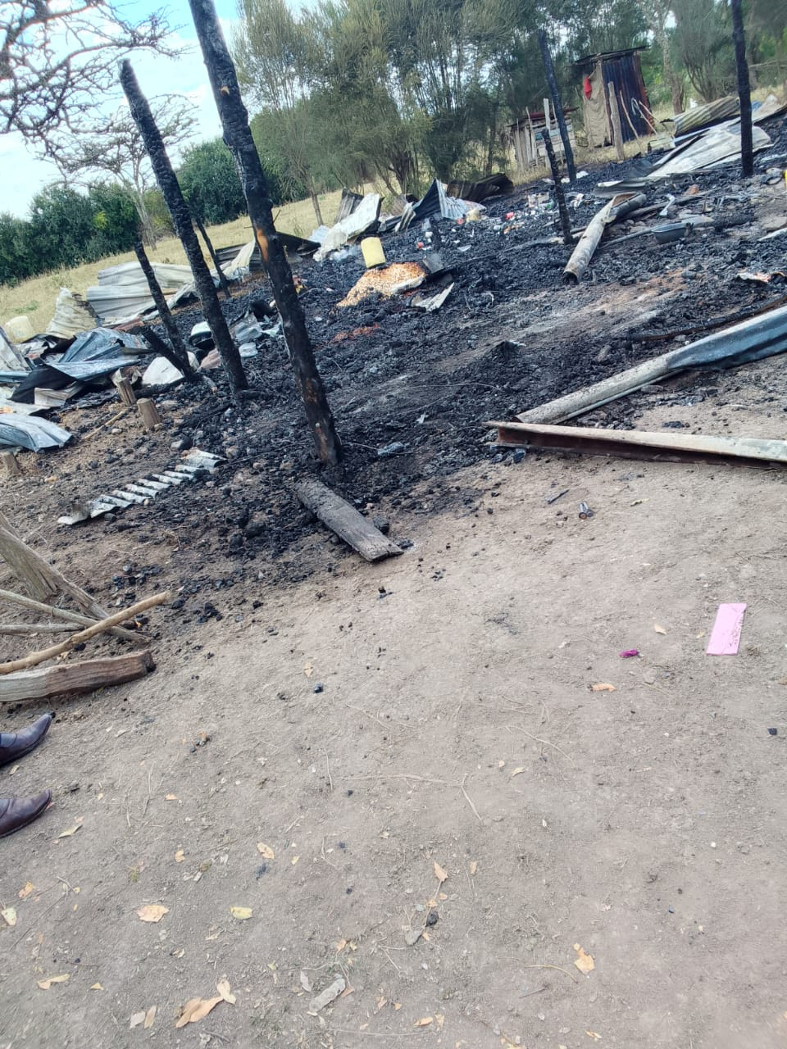

***Report Compiled by:***

**Name of Officer: Doris Mwangi Designation; SWO - Othaya Date: 16/10/2024 Signature: DWM**